TEXT, UNIFORM and KIT LIST

LEVEL 2 BEAUTY THERAPY COURSES:

VTCT Evidence file – individual units (7.50) or full Diploma (35.00 for 9 units)

CENGAGE Textbooks - 40% Discount:
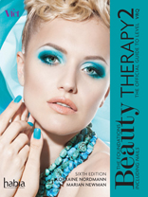 | The Official Guide to Level 2 VRQ  Lorraine Nordmann, Hugh Baird College  576pp  Published by Cengage Learning, ©2014  Available Now  £27.99

FACIALS:
- The Official Guide to Level 2 VRQ
- Uniform
- Facial kit which includes: sponges; mask brush; mitts; headband; cleansing brush; wooden spatulas; cotton wool pads; tissues; cotton buds
- Skincare product range: cleanser; toner; moisturiser; masks (setting/ non setting); massage oil/cream; exfoliator

MANICURE AND PEDICURE:
- The Official Guide to Level 2 VRQ
- Uniform
- Manicure and pedicure kit which includes: hand soak bowl; emery boards; wooden orange sticks; wooden spatulas; cuticle knife; hoof stick; nail buffer; nail scissors; cuticle nippers; hard skin remover; foot bath; cotton wool pads; tissues; cotton buds; mitts; heated mitts/ boots; vinyl gloves (optional)
- Manicure/ pedicure product range and nail colours: hand/ foot sanitiser; buffing paste; cuticle cream; cuticle remover; hand / foot cream; hand/ foot exfoliator; hand/ foot soak; hand/ foot mask; range of nail colours; top and base coat

LASH AND BROW TREATMENTS:
- The Official Guide to Level 2 VRQ
- Uniform
- Lash and brow kit which includes: tweezers; tint brush; tint bowl; cotton wool pads; tissues; cotton buds
- Lash and brow tinting product range: eye cleanser; range of tint colours (brown, grey, black, blue); peroxide

DEPILATION:
- The Official Guide to Level 2 VRQ
- Uniform
- Wax kit which includes: wax pot; wax strips; wooden spatulas; cotton wool pads; tissues; vinyl gloves
- Waxing product range: warm wax; hot wax; pre wax lotion; post wax lotion; surgical spirit

MAKEUP:
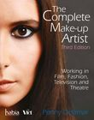 | Penny Delamar, Founder, The Delamar Academy, Ealing Film Studios, London  352pp  Published by Cengage Learning, ©2016  Available Now  £27.99
Or The Official Guide to Level 2 VRQ
- Uniform
- Makeup kit which includes: brushes; headband; foundation sponges; spatulas; cotton wool pads; tissues; cotton buds
- Makeup product range: full makeup kit including corrective; brush cleaner

LEVEL 3 MASSAGE THERAPY COURSES:

(Waiting for VTCT evidence file)

CENGAGE Textbooks - 40% Discount:
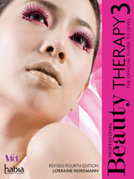 | The Official Guide to Level 3 (Revised Edition)  Lorraine Nordmann, Hugh Baird College  586pp  Published by Cengage Learning, ©2014  Available Now  £35.99

MASSAGE:
- The Official Guide to Level 3
- Uniform
- Massage kit which includes: Couch; towels; oil dispenser; cotton wool pads; spatulas
- Massage product range: massage oil (almond); massage cream; foot sanitiser

STONE MASSAGE:
- The Official Guide to Level 3
- Uniform
- Stone massage kit which includes Couch; Stone tank and selection of hot and cold stones; towels; oil dispenser; cotton wool pads
- Stone massage product range: massage oil (almond); pre-blended massage oils (optional); foot sanitiser

PRE BLENDED AROMATHERAPY:
- The Official Guide to Level 3
- Uniform
- Pre-blended kit which includes: Couch; Towels; oil dispenser; cotton wool pads
- Pre-blended aromatherapy product range: pre-blended face and body oils for relaxation, uplifting, sense of well-being, stimulating; foot sanitiser

INDIAN HEAD MASSAGE:
- The Official Guide to Level 3
- Uniform
- Indian head kit which includes: Table top support; towels; oil dispenser
- Indian Head massage product range: pre-blended oils for relaxation, sense of wellbeing, uplifting, improvement of hair and scalp condition

EPILATION:
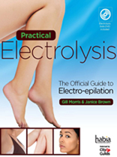 | The Official Guide to Electro-epilation  Gill Morris, Managing Director of the GMT Group and a founding member of HABIA  Janice Brown, Managing Director of House of Famuir and a HABIA Industry Forum Member  280pp  Published by Cengage Learning, ©2012  Available Now  £32.99
- Or The Official Guide to Level 3
- Uniform
- Epilation kit which includes: Blend epilation machine; needle holder; range of needles (sizes 2/3/4); epilation tweezers; tissues; cotton wool pads; vinyl gloves
- Epilation product range: pre-epilation sanitizer; post-epilation soothing lotion

LEVEL 3 COMPLEMENTARY THERAPIES:

(ETS or Cengage)

MASSAGE:
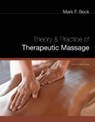 | Mark F. Beck, American Massage Therapy Association  992pp  Published by Cengage Learning, ©2011  Available Now  £39.99

- Uniform
- Massage kit which includes: Couch; Towels; oil dispenser; cotton wool pads; spatulas
- Massage product range: massage oil (almond); massage cream; foot sanitiser

AROMATHERAPY:
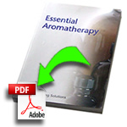 Essential Training Solutions: Aromatherapy DOWNLOAD £8.99

- Uniform
- Aromatherapy kit which includes: Couch; Towels; oil dispenser; measure cup; cotton pads
- Aromatherapy product range: full essential oil kit- Lavender, Clary sage, Marjoram, Rosemary, Thyme, Basil, Patchouli, Neroli, Petitgrain, Bergamot, Chamomile, Roman, Chamomile, German, Eucalyptus, Tea tree, Geranium, Pepper, black, Fennel, Rose, damask; carrier oils – Almond, Peach Kernel, Grapeseed, Avocado, Macadamia, Evening Primrose, Wheatgerm, Jojoba; foot sanitiser

CHECK SUPPLIERS

REFLEXOLOGY:
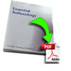 Essential Training Solutions: Aromatherapy DOWNLOAD £8.99

- Uniform
- Reflexology kit which includes: Couch/ reclining chair; Towels; pillows; cotton pads
- Reflexology product range: foot cream; foot sanitizer; vinyl gloves

ANATOMY AND PHYSIOLOGY:
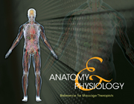 | Milady,  33pp  Published by Cengage Learning, ©2013  Available Now  £11.99  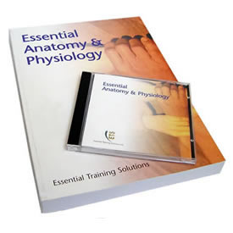Essential Training Solutions: Manual - £29.99
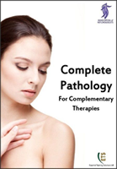 Essential Training Solutions: Manual - Just £15.99

HEALTHY EATING AND WELLBEING:

LEVEL 4 QUALIFICATIONS:

SKIN BLEMISH REMOVAL:
- Uniform
- Epilation kit which includes: Blend epilation machine; needle holder; range of needles (sizes 5-10); epilation tweezers; tissues; cotton wool pads; vinyl gloves
- Epilation product range: pre-epilation sanitizer; post-epilation soothing lotion

L4 STRESS MANAGEMENT STRATEGIES:

LEVEL 4 AROMATHERAPY

LEVEL 4 REFLEXOLOGY

LEVEL 4 DIPLOMA IN COMPLEMENTARY THERAPIES

